Частина «ЧИТАННЯ»
Reading
Task 1
Read the texts below. Match choices (A-H) to (1-5). There are three choices you do not need to use. Write your answers on the separate answer sheet.
Top Five Study Tips
1._________________
Make sure you have all the materials you need at hand before you start studying. Getting up to look for a pencil sharpener or ruler will break your concentration and waste your time.
2._________________
Think about what it will mean for you if you do well in your studies. How will it make you feel? If you keep the end result in mind it will help you succeed in studying. You might like to find an image or something that represents success for you and put it somewhere you can see it while you're studying.
3._________________
Use a calendar or a list of dates or a wall planner to keep track of exam dates and assignment due dates. Space out your study time each week for the whole term/semester - don't try to cram it all in the night before!
Do the hardest work when you're feeling your best. Save the easy stuff for when you're tired.
Set yourself a time limit for each task and follow it.
4._________________
You study better when you're feeling good. So make sure you eat well and get enough sleep. Exercise is great but don't overdo it.
It's also a good idea to schedule regular breaks when you're studying and keep hydrated. If you follow these steps you will study better.
5._________________
Taking detailed notes in class or at home will save you a lot of time later. Re-writing and adding to your notes is a great way to revise what you've learned.
A Organize your working space
B Take care of yourself
C Plan your time
D Clear your mind
E Get motivated
F Get creative
G Socialize and relax
H Write down and review

Task 2
Read the text below. For questions (6-10) choose the correct answer (A, B, C or D). Write your answers on the separate answer sheet.
A Different Way to Wake Up
By Catherine Clarke Fox

Matty Sallin's alarm clock wakes you up with the aroma of sizzling bacon.
When Matty Sallin, 34, was working on a degree in art and technology at New York University, he got an interesting assignment in electronics class: Create something for 5 the household. He decided to create an alarm clock.
"Everybody has to deal with these every day, and they are extremely unpleasant!" he says. He asked different people what they'd like to wake up to instead of a clanging, noisy alarm. A lot of them said, "The smell of bacon."
So Sallin and two classmates invented a new kind of alarm clock: a wooden box with a pig face and a digital clock that uses the smell of cooking bacon rather than sound to wake someone up. He explains, "There's no danger of burning, because I built it carefully. It uses halogen light bulbs instead of a flame for cooking and turns off automatically after ten minutes." Just a few easy steps are required to set the "alarm".
"What you do is put a couple of frozen strips in the night before," says Sallin. Bacon is cured, or preserved, so there is no danger of it spoiling overnight.
"If you set the alarm for 8:00, it will turn on at 7:50 and slow cook for ten minutes under the halogen bulbs", he says. Then the bulbs turn off and a fan blows the scent out through the nostrils of the pig.
"So instead of an alarm or a beep or a radio, you smell yourself awake", says Sallin. "Then you can open the door on the side and pull the bacon out and eat it."
When Sallin was a kid, he spent a lot of time making drawings of inventions. "I wanted to make an elevator in my back yard and a special tree house," he says. "But I never really thought I'd be called an inventor!"
Sallin got an A in the class and went on to other things - but people continue to hear about his invention and email him every day asking where they can buy his alarm clock.
These days he designs computer software, but if he decides to produce and sell his aroma alarm, maybe he can develop some other models. Any votes for cinnamon buns?

6. Which of the following is TRUE about Matty Sallin?
A He taught at New York University.
B He liked fried bacon for breakfast.
C He got the idea of his alarm clock from others.
D He got up at 8 in the morning when a student.

7. What does the word "they" in line 7 stand for?
A household chores
B assignments
C alarm clocks
D classes

8 Which is NOT mentioned in the text about the new alarm clock?
A It's safe to use.
B It's popular with people.
C It's a result of team work.
D It's available in several models.

9 What is Matty working on now?
A computer programs
B a backyard elevator
C a cinnamon alarm
D halogen bulbs

10 Which of the following does the author mention in the text?
A Matty was given the task to make an alarm clock.
B Matty was successful in selling his aroma alarm.
C Matty's alarm gives three beeping sounds.
D Matty's alarm clock fulfils two functions.

Task 3

Read the texts below. Match choices (A-H) to (11-16). There are two choices you do not need to use. Write your answers on the separate answer sheet.
11 Diego G., Virginia
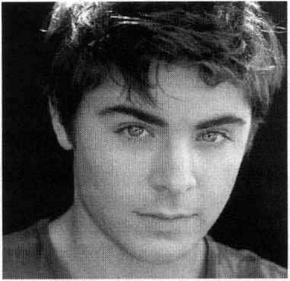
When I step onto the trail that borders Rocky Run Stream, the civilized world quickly disappears. I think the only one who likes exploring these waters more than I do is my big brown dog, Paisa. He eagerly splashes around, and lets the water come up to his neck.
12 Madeline L., Texas
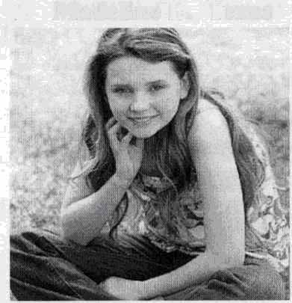While exploring the Redwoods last summer, my family walked down to the Eel River. We couldn't swim in the river because of blue green algae warnings, so we decided to make water peepers to help us see down further into the water without going all the way in. We saw water insects, fish, and a snake swimming by.
13 Kennan N., Florida
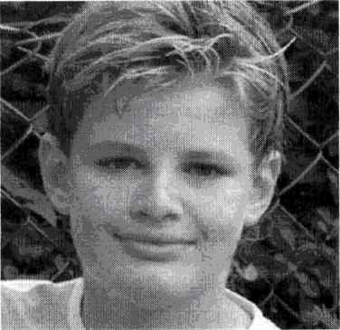I monitor the water level of my pond to discover the effects of heavy rains and drought. This lets me know when I need to water my plants and when there has been sufficient rainfall. I also like to study the water quality in the pond. Exploring water has become my passion and one day it will be my career.
14 Michael P., New York
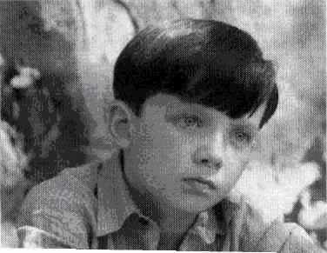The timid, green, Asian Shore Crab froze when confronted with my towering metallic camera lens. I held my breath and focusing on the animal in front of me, 1 clicked, capturing the moment forever. Photography permits me to discover our planet and myself at the same time. By taking these pictures I can share my excitement for exploration with friends.
15 Jonathan S. Massachusetts
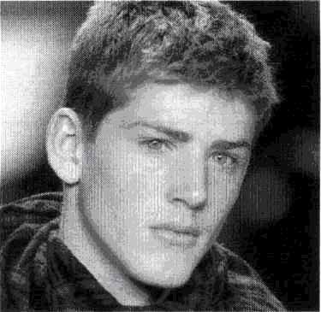Making my descent, I can't help feeling claustrophobic and anxious.- I've waited for this moment forever and now I'm so nervous. Since my twelfth birthday I've read and studied. Full of knowledge, with a scuba license and lots of gear weighing me down, I sink into the warm Caribbean Ocean - a place I've only imagined about visiting.
16 Kobie B., New Mexico
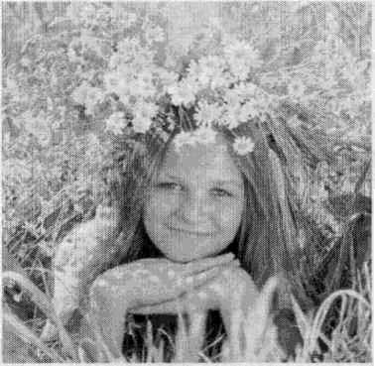I love to hike up to our favorite camping spot in one of the canyons. The majesty of the mountains overwhelms me as I search for caddis fly larvae beneath the pebbles in the stream and it saddens me to think of all the water going to waste in my city while I splash around to my heart's content.
Who of the kids____________?
A goes exploring with a pet
B worries about using too much water
C dreams of far-away voyages
D would like to be a water expert
E shows experiences to others
F found an alternative way to view water life
G has prepared for the exploration experience
H likes long boating trips

Task 4
Read the text below. Choose from (A-H) the one which best fits each space (17-22). There are two choices you do not need to use. Write your answers on the separate answer sheet.
Music for the Soul
It is impossible for me (17)________ when it comes to the subject of music or the music program in school. I have been in my school's band since I was in the sixth grade. The unity and structure of the music caught my ear and pulled me in (18)________. I was interested in how so many instruments could all have different parts and still fit together (19)___________. I toyed with the thought of playing multiple instruments before I decided to follow my big brother's footsteps and invest in a saxophone. Six years have passed since (20)_________________ for the first time and I still enjoy playing.
Although I do view my school as a very fun and exciting place with eccentric teachers and great students, I would not enjoy it if it was (21)__________ For the people in a band, music class is an escape from the math, English, and science classes they take every day. Music is a way for students (22)___________. As a music fan, I sleep, read, and do homework better when there is music constantly playing in the background.

A the lack of live music
B holding my saxophone
C lacking a music program
D like a fish at the end of a line
E like a jigsaw puzzle
F showing up to play for them *
G to be completely objective
H to relax from the tension of homework or tests

Частина «ВИКОРИСТАННЯ МОВИ»
Use of English
Task 5
Read the text below. For questions (23-32) choose the correct answer (A, B, C or D). Write your answers on the separate answer sheet.
This Week's Dream
Most pubs in Bermuda have two TVs, one for cricket and one for baseball. In recent decades, American cultural (23)____________ over this little archipelago in the western Atlantic has been strong, but it remains a British Overseas Territory - the oldest of all. Bermuda is old-fashioned, democratic and very friendly - (24)____________ the eye of any stranger in the street and they'll smile and say hello.
The island was known (25)_____________________ the Spanish but still uninhabited in 1609, when Sir George Somers ran aground on a sandbank in a storm and (26)? A; it for the Crown. The "pretty" town of St George's, which he founded, is the oldest English (27)__________ in the New World.
Pink is the island's "defining colour". It's a popular shade for the neatly pressed Bermuda shorts (28)_____________ by some locals (usually with a jacket and a tie). Many of the island's bungalows are pink, its buses are pink - and so are its beaches, (29)_______________ to grains of coral in the sand. (30)____________ Bermuda's other natural wonders are Crystal Cave – a cavern complex with stalagmites and stalactites - and its rich bird's life: like Prospero's isle, "(31)__________ of noises, sounds and sweet airs", Bermuda "thrums to the sound of birdsong (32)_________ dawn and twilight".
23 | A | effect | B | presence | C | influence | D | introduction
24 | A | get | B | catch | C | hold | D | take
25 | A | in | B | at | C | to | D | for
26 | A | devoted | B | requested | C | dedicated | D | claimed
27 | A | community | B | group | C | public | D | audience
28 | A | put | B | dressed | C | carried | D | worn
29 | A | in order | B | because | C | thanks | D | in spite
30 | A | Within | B | Along | C | Between | D | Among
31 | A | filled | B | packed | C | rich | D | full
32 | A | at | B | in | C | on | D | by

Task 6
Read the texts below. For questions (33-42) choose the correct answer (A, B, C or D). Write your answers on the separate answer sheet.
Japan under Snow
Why do so few of us think of (33)___________ Japan in winter? On the north island of Hokkaido, snow is as (34)_____________ as in Finnish Lapland, but it's not as cold. And the resorts are (35)________________ managed and the facilities are first-class. At Rusutsu there are 18 miles of groomed trails, catering to all abilities, through well-spaced birch and bamboo forests. Niseko is even (36)___________, with 30 miles of trails and plenty of off-piste too. After a hard day in this "Oriental (37)__________ wonderland" you can visit a traditional onsen for a shiatsu massage and a dip in the steam bath, guaranteeing a good night's sleep.
33 | A | visit | B | visited | C | visits | D | visiting
34 | A | guaranty | B | guaranteed | C | guarantee | D | guaranteeing
35 | A | beauty | B | beautifully | C | beautify | D | beautiful
36 | A | bigger | B | biggest | C | big | D | the biggest
37 | A | winters | B | winters' | C | winter | D | winter's
The Turkey Pardon
Each year at Thanksgiving, the President of the United States (38)____________ a gift of a live turkey (along (39)_______________ an alternate in case_something (40)_________ to the official turkey). At a White House ceremony, the president (41)________ "pardons" the National Thanksgiving Turkey and the alternate turkeys, allowing them (42)___________ out the rest of their lives on a farm.
38 | A | receive | B | receives | C | is receiving | D | received
39 | A | with | B | of | C | for | D | in
40 | A | happens | B | will happen | C | happen | D | is happening
41 | A | traditionary | B | traditional | C | tradition | D | traditionally
42 | A | live | B | living | C | to live | D | lived
Частина «ПИСЬМО»
Writing
43. You have received a letter from your pen-friend in which he/she complains that his/ her parents want him/her to read classical authors, while he/she is fond of fantasy. Write a letter to your pen-friend in which you tell him/her
- whether your parents influence your choice of books to read
- what is your favorite literary genre and why
- where you usually get books you'd like to read
Write a letter of at least 100 words. Do not use any personal information (e. g., names dates, addresses, etc.). Start your letter in an appropriate way.

